Nama : Umar Ulkhak

NIM : 17090008

Kelas : 5A

Laporan Praktikum 5

1. Source Code

MatakuliahValidation.php 🡪 application/controllers/

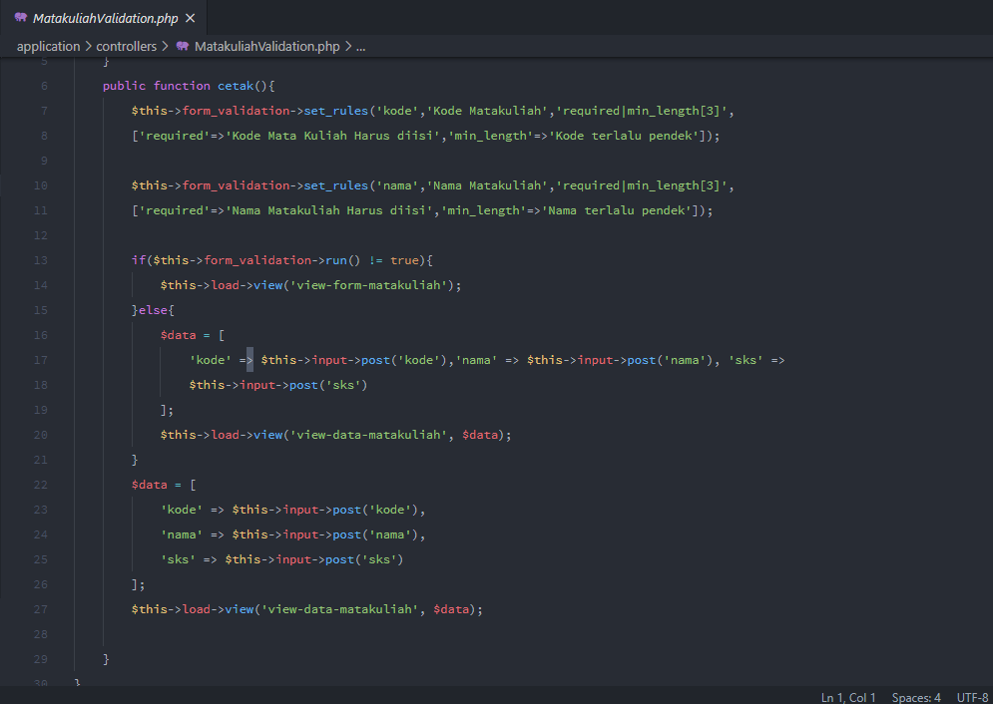

autoload.php 🡪 application/config/

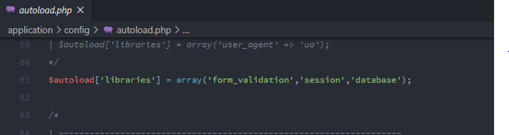

view-form-matakuliah.php 🡪 application/views/

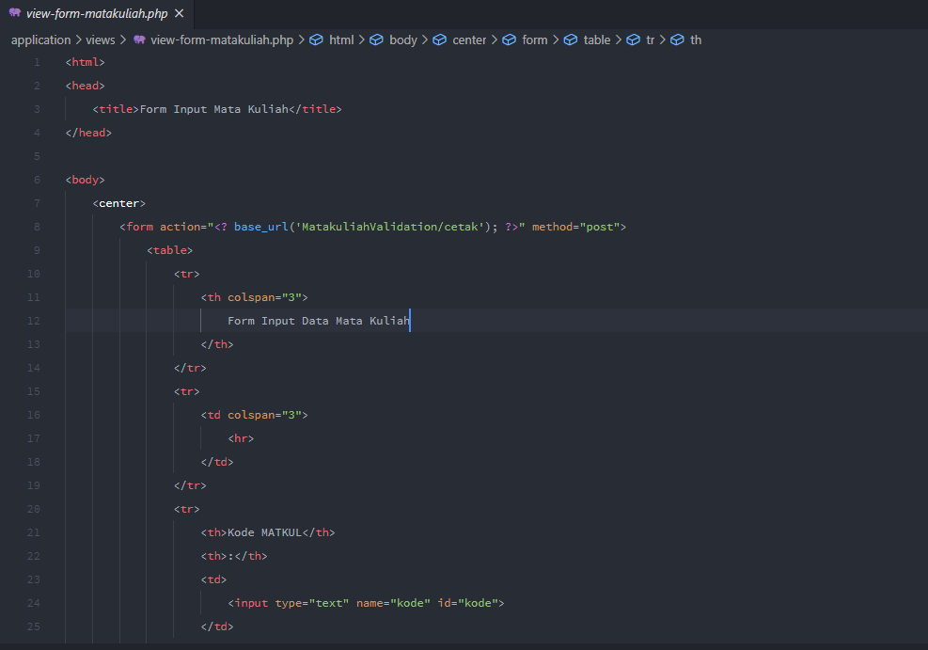

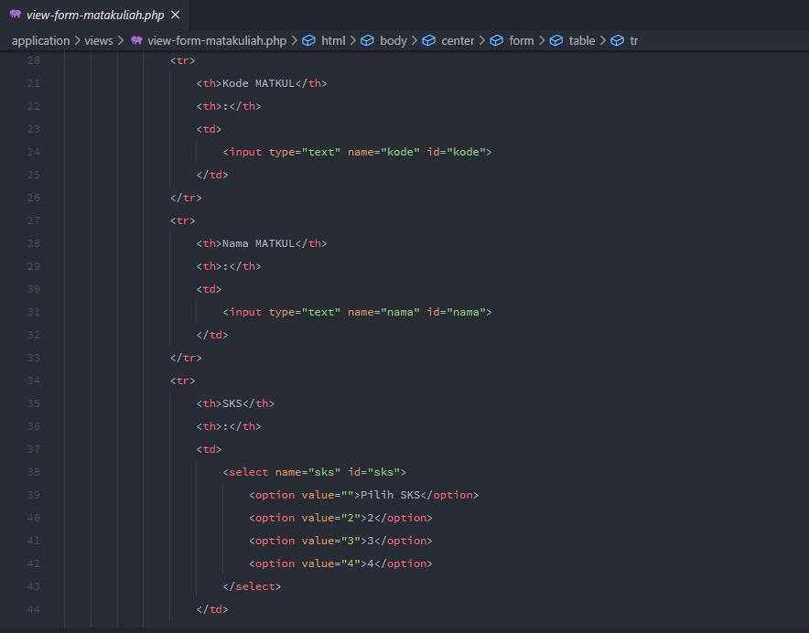

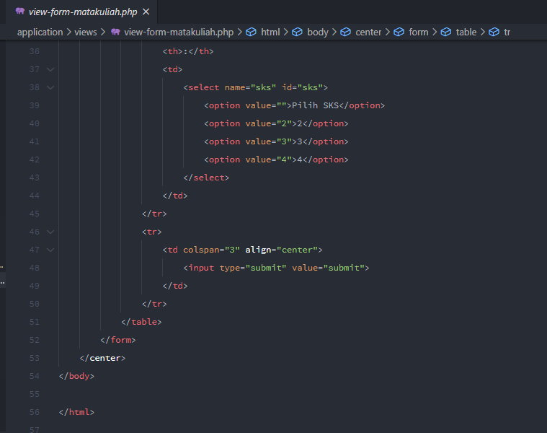

1. URL

<http://localhost/pustaka-booking/MatakuliahValidation>

1. Capture Output Program

